### Internship 2022

# Progress report format for team meeting

Name: Cynthia Kemboi

## Tasks completed last week

* [#9] Circuit diagram of the robot car- The circuit diagram for the robot car was drawn using fritzing software.
* [#16] Definition of the path followed by the robot car. For our robot to follow the correct path during the tillage process, a path has to be defined to ensure that all the areas of the farmland is well tilled.

This the path that our robot car should follow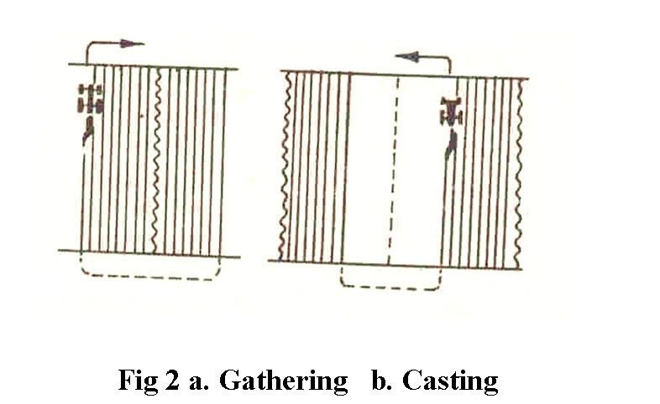

Circuit diagram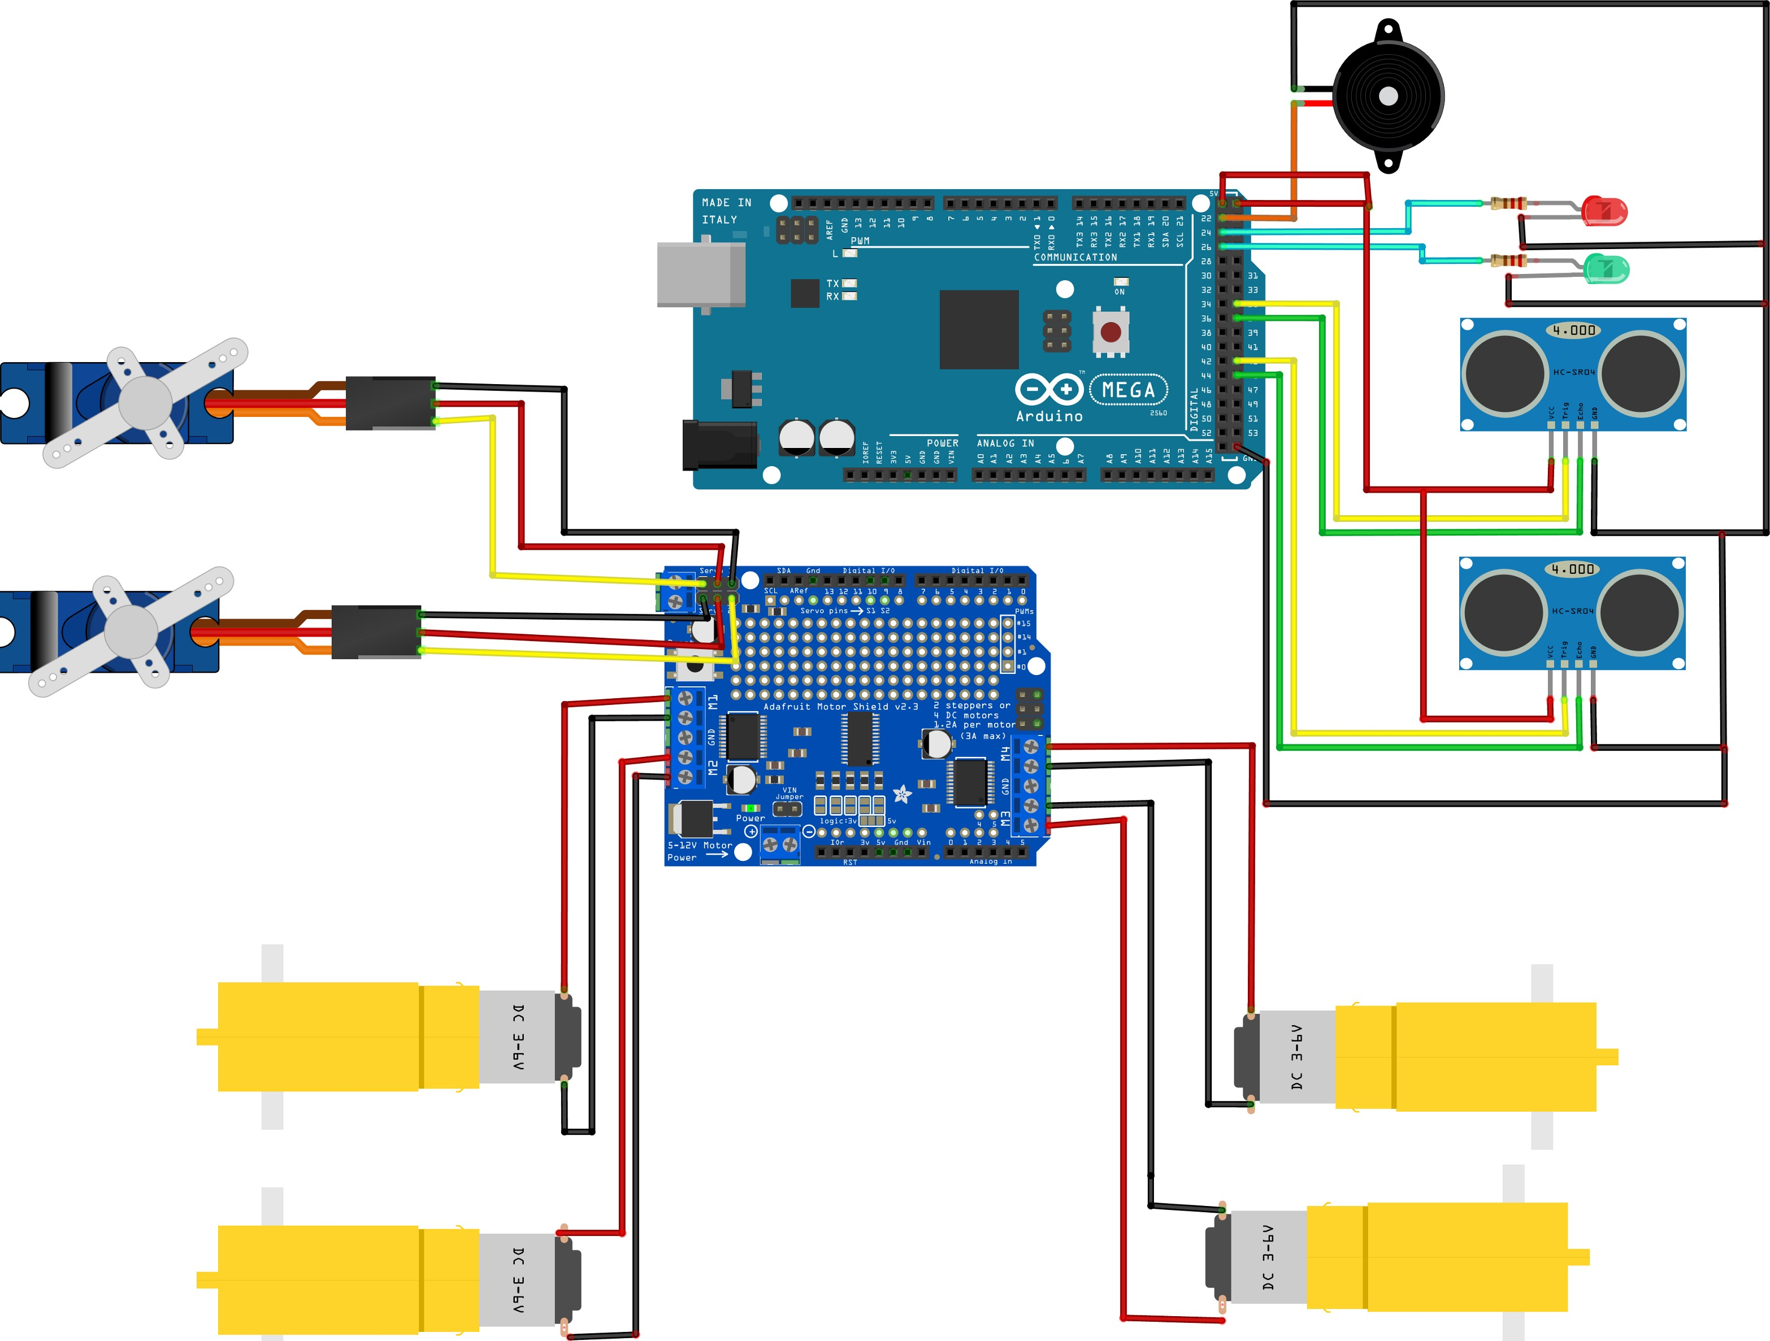

## Tasks in this week

* [#15] Redesign of the chassis diagram- There are some changes that need to be made in the chassis drawing.

## Timeline

|  |  |  |
| --- | --- | --- |
| Month | Intern week | Tasks |
| Jan |  |  |
| Week 1 | Identification of parts and drawing of the chassis diagram |
| Week 2 | Circuit diagram and acquisition of parts. |
| Week 3 | Definition of the path to be followed by the robot car |
| Feb | Week 4 |  |
| Week 5 |  |
| Week 6 |  |
| Week 7 |  |